Mood Tracker
NAME ___________________________
DATE ____________________________

Dr. Ilene Naomi Rusk
 |  | Monday | Tuesday | Wednesday | Thursday | Friday | Saturday | Sunday
Morning | Emotion
 | Rating
Afternoon | Emotion
 | Rating
Evening | Emotion
Ilenenaomirusk.com

Instructions:
- Choose several times each day to record your mood and how you are feeling.
- Use the emotion wheel below to identify the basic feeling you're having (central circle) and then choose descriptors from the second level circle. Rate the intensity of each feeling from 1 (slight or barely at all) to 10 (the strongest feeling I can have).
- Feel free to note that any relevant background. For example:
1. What was happening, where were you, and who are you with?
2. What went through your mind (thoughts or images)?
3. What were you doing just before you felt this way?
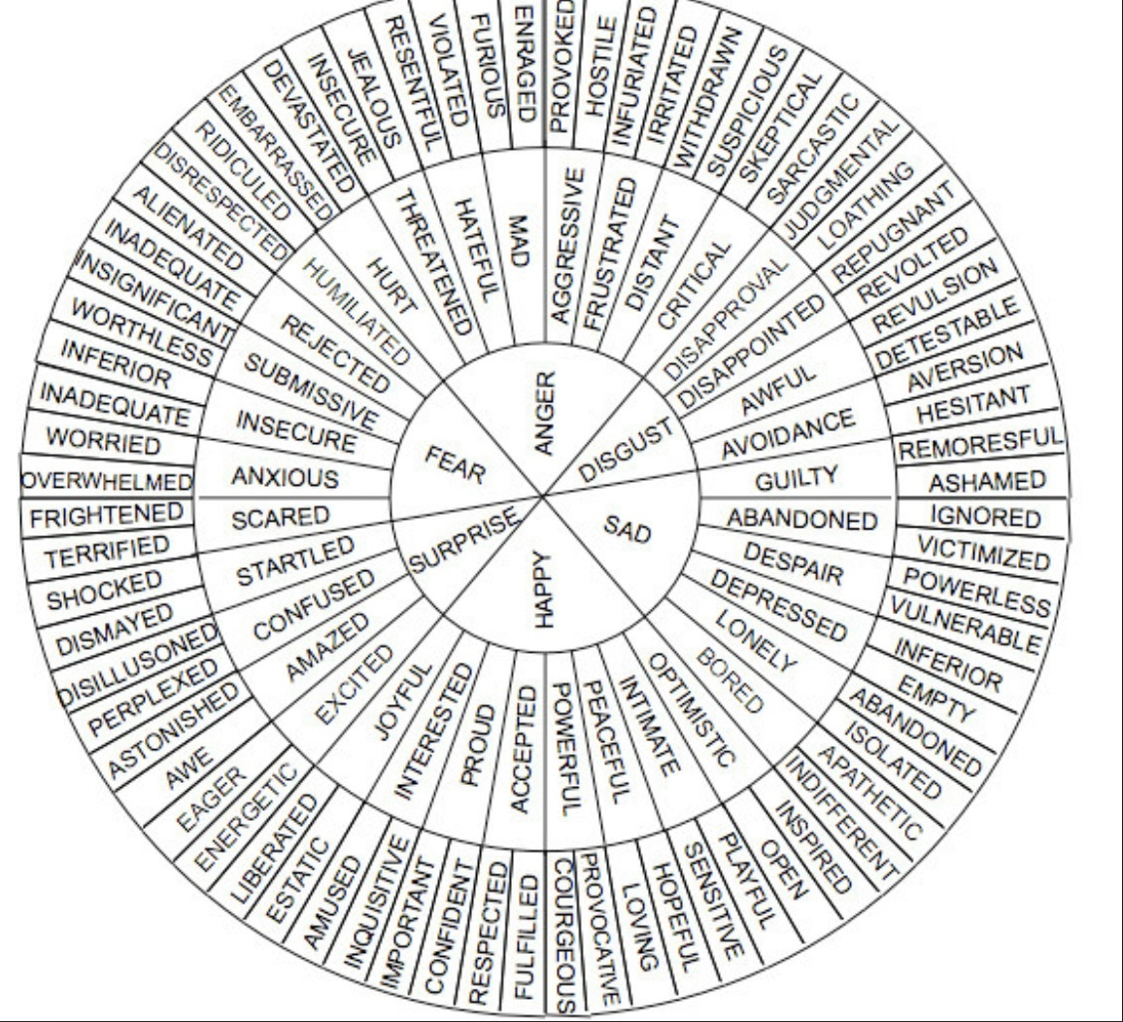
Dr. Ilene Naomi Rusk
HealthyBrain.Clinic

